**Circadian Clock-Gene Structure Couples with PD-L1**  
**Across Six Cancer Types and Defines**  
**Survival-Associated Subtypes in Melanoma**

Moses Rahnama  
Mina Analytics  
moses@minaanalytics.com  
February 2026

**Abstract.** **Background.** Circadian disruption is classified by IARC as a probable human carcinogen (Group 2A). The relationship between clock-gene expression structure and immune checkpoint engagement across cancer types is poorly characterized. We hypothesized that circadian program state and PD-L1 engagement are coupled, reflecting distinct modes of immune evasion.

**Methods.** We analyzed bulk RNA-seq and clinical data from six TCGA cohorts ( $n=3,611$ tumors; SKCM, LUAD, BRCA, COAD, HNSC, LUSC). Per-sample circadian coefficient of variation (CV) across six clock genes (ARNTL, CLOCK, PER1, PER2, CRY1, CRY2) served as a transcriptional clock-structure proxy. Tumors were classified as Active Masking (high PD-L1 + high BMAL1 + low PER1) or Temporal Decoherence (low PD-L1 + low B2M). Survival used Kaplan-Meier, log-rank, and RMST on a deduplicated cohort ($n=3,089$). Sensitivity analyses included threshold sweeps, immune-fraction residualization, purity stratification, and an independent observability index.

**Results.** Circadian CV was negatively correlated with PD-L1 in all six cohorts ( $ρ=-0.125$ to $-0.381$, all FDR $q<0.05$). Tumors showed lower CV than matched normals in 4/5 types (“locked, not broken”). Active Masking showed better survival than Decoherence in melanoma (log-rank $p=0.0011$, BH $q=0.0132$; RMST $+24.2$ months at 10 years, 95% CI $10.8-36.8$). The signal was robust to threshold choice (9/11 percentiles significant), survived immune residualization (4/4 cohorts), and was captured by an independent observability index ($p<2×{10}^{-10}$). A continuous PD-L1 $×$ clock interaction term was FDR-significant in melanoma (Cox HR $=0.217$, $q=0.045$), indicating non-additive coupling. The negative direction was consistent in 3/3 external immunotherapy cohorts (GSE91061 melanoma $ρ=-0.283$, $p=0.049$; GSE78220 melanoma $ρ=-0.283$; GSE115821 melanoma $ρ=-0.222$; individually underpowered, directionally consistent across 9/9 datasets).

**Conclusions.** Circadian clock-gene structure and checkpoint engagement are coupled across six cancer types. Active Masking and Decoherence define two immune-evasion endpoints with a melanoma-dominant survival association and a significant checkpoint-clock interaction effect that motivates prospective testing as a complement to existing immunotherapy biomarkers.

# Introduction

Circadian disruption is increasingly recognized as a cancer hallmark. The International Agency for Research on Cancer (IARC) classified night shift work involving circadian disruption as a probable human carcinogen (Group 2A) . Prospective cohort studies of nurses show elevated breast cancer risk after 20+ years of rotating night shifts (RR = 1.79; 95% CI 1.06-3.01). Finnish twin cohort data show HR = 1.58 (95% CI 1.16-2.15) for breast cancer among night shift workers, with the critical factor being circadian disruption specifically, not shift work per se. At the molecular scale, core clock components CLOCK and BMAL1 have tumor-suppressive roles: BMAL1 activates ATM signaling for G2/M arrest in colorectal cancer, and the CLOCK-BMAL1 heterodimer suppresses c-Myc-mediated Cyclin E activation in melanoma and colorectal models . Genetic ablation of BMAL1 promotes lung tumorigenesis by increasing c-Myc activity and glutamine use . Distant tumors can also rewire circadian metabolism in other organs; lung adenocarcinoma alters hepatic STAT3-Socs3 signaling without changing core liver clock genes .

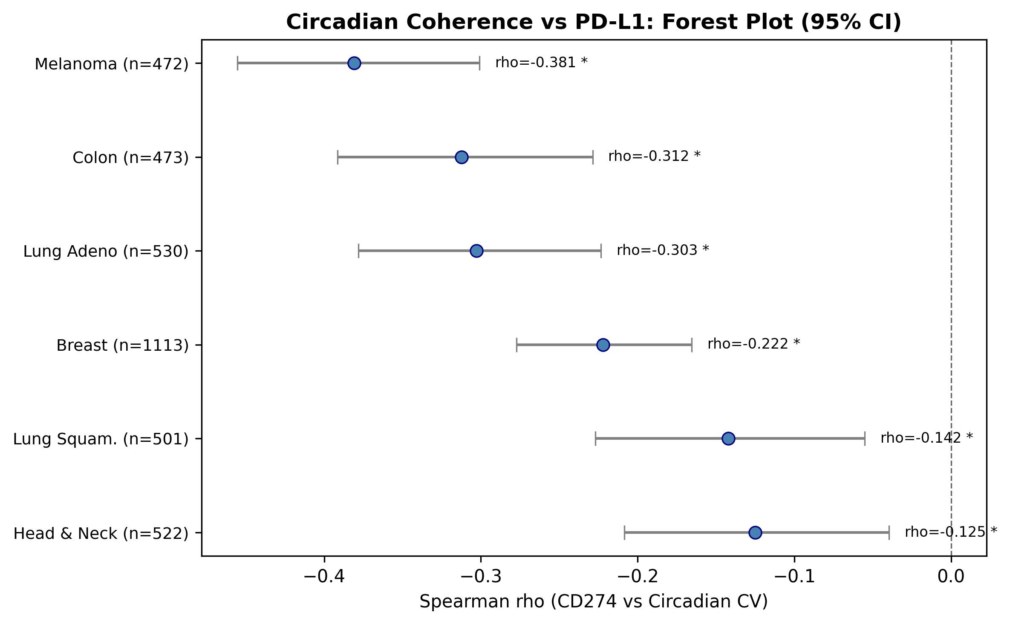

**Core finding: circadian clock-gene dispersion couples with PD-L1 across six cancer types.** Spearman correlations between within-sample circadian CV and CD274 (PD-L1) expression across six TCGA cohorts ( $n=3,611$ tumors). All six effects are negative and FDR-significant ( $ρ=-0.125$ to $-0.381$, all $q<0.05$). Higher PD-L1 tracks lower clock-gene dispersion consistently across tissue contexts.

The PD-1/PD-L1 checkpoint axis is the immune system’s primary mechanism for self-tolerance;and a pathway exploited by cancer for immune evasion . PD-1 is a checkpoint receptor on T cells that limits excessive stimulation; tumor PD-L1 engages PD-1 and suppresses T-cell activation, enabling immune escape. Checkpoint inhibitor therapy (anti-PD-1/PD-L1 antibodies) restores immune visibility by blocking this false “self” signal . Some cancers develop resistance through secondary boundary failures: JAK1/JAK2 mutations impairing interferon- $γ$ responsiveness, loss of $β$ 2-microglobulin eliminating MHC class I surface expression, and PTEN loss decreasing T cell infiltration . Cancer immunoediting;the “Three Es” framework of Elimination, Equilibrium, and Escape ;describes how tumors evolve under immune pressure. Understanding the Escape phase requires distinguishing between mechanistically different evasion routes. Emerging evidence now directly links clock components to checkpoint regulation: the circadian gene RORA suppresses PD-L1 transcription via an HDAC3 complex in melanoma , CLOCK acetylates NF- $κ$ B p65 to drive PD-L1 expression in breast cancer , and PD-L1-expressing myeloid-derived suppressor cells peak rhythmically in colorectal tumors, with time-of-day anti-PD-L1 delivery achieving maximal efficacy when synchronized with this peak . These mechanistic findings suggest that circadian and checkpoint biology are not independent hallmarks but coupled systems.

Despite extensive work on both circadian disruption and immune checkpoint biology individually, the relationship between clock-gene expression *structure*;the coordinated multi-gene program, not individual genes;and immune checkpoint engagement has not been systematically characterized across cancer types. De Assis et al.  showed that BMAL1 expression positively correlates with T-cell markers and immunotherapy benefit in metastatic melanoma, and Wu et al.  demonstrated that disrupted clock genes associate with T-cell exhaustion and PD-L1 upregulation pan-cancer. However, neither examined the *within-sample structural coherence* of the clock program or tested the coupling across individual cancer types. We frame this question through what we term a “boundary-failure” lens. In multicellular organisms, the immune system, circadian program, and intercellular communication channels (gap junctions, adhesion molecules) collectively maintain the operational boundary between “self” and “aberrant”;the set of mechanisms by which the organism detects and eliminates cells that no longer comply with tissue-level regulation . We define *boundary failure* as degradation of this detection-and-response capacity, whether through active suppression of immune clearance (e.g., PD-L1 upregulation) or through loss of the signals that make aberrant cells detectable (e.g., MHC-I downregulation). This framing predicts that different modes of boundary failure should show different circadian architectures. We define two subtypes: *Active Masking* (AM), where the tumor retains a restructured clock and deploys PD-L1 to veto immune clearance;the cell is detectable but the response is suppressed; and *Temporal Decoherence* (DC), where the tumor has lost both checkpoint engagement and antigen-presentation capacity;the cell is effectively undetectable. The full theoretical framework, including a formal treatment of cross-scale observability, is developed elsewhere .

Here we analyze six TCGA cohorts ( $n=3,611$ tumors) to test: (i) whether this coupling (Figure 1) generalizes across cancer types, (ii) whether tumors show restructured versus broken clocks relative to matched normals, (iii) whether boundary-failure subtypes associate with survival, and (iv) whether signals survive stromal confounding and external replication.

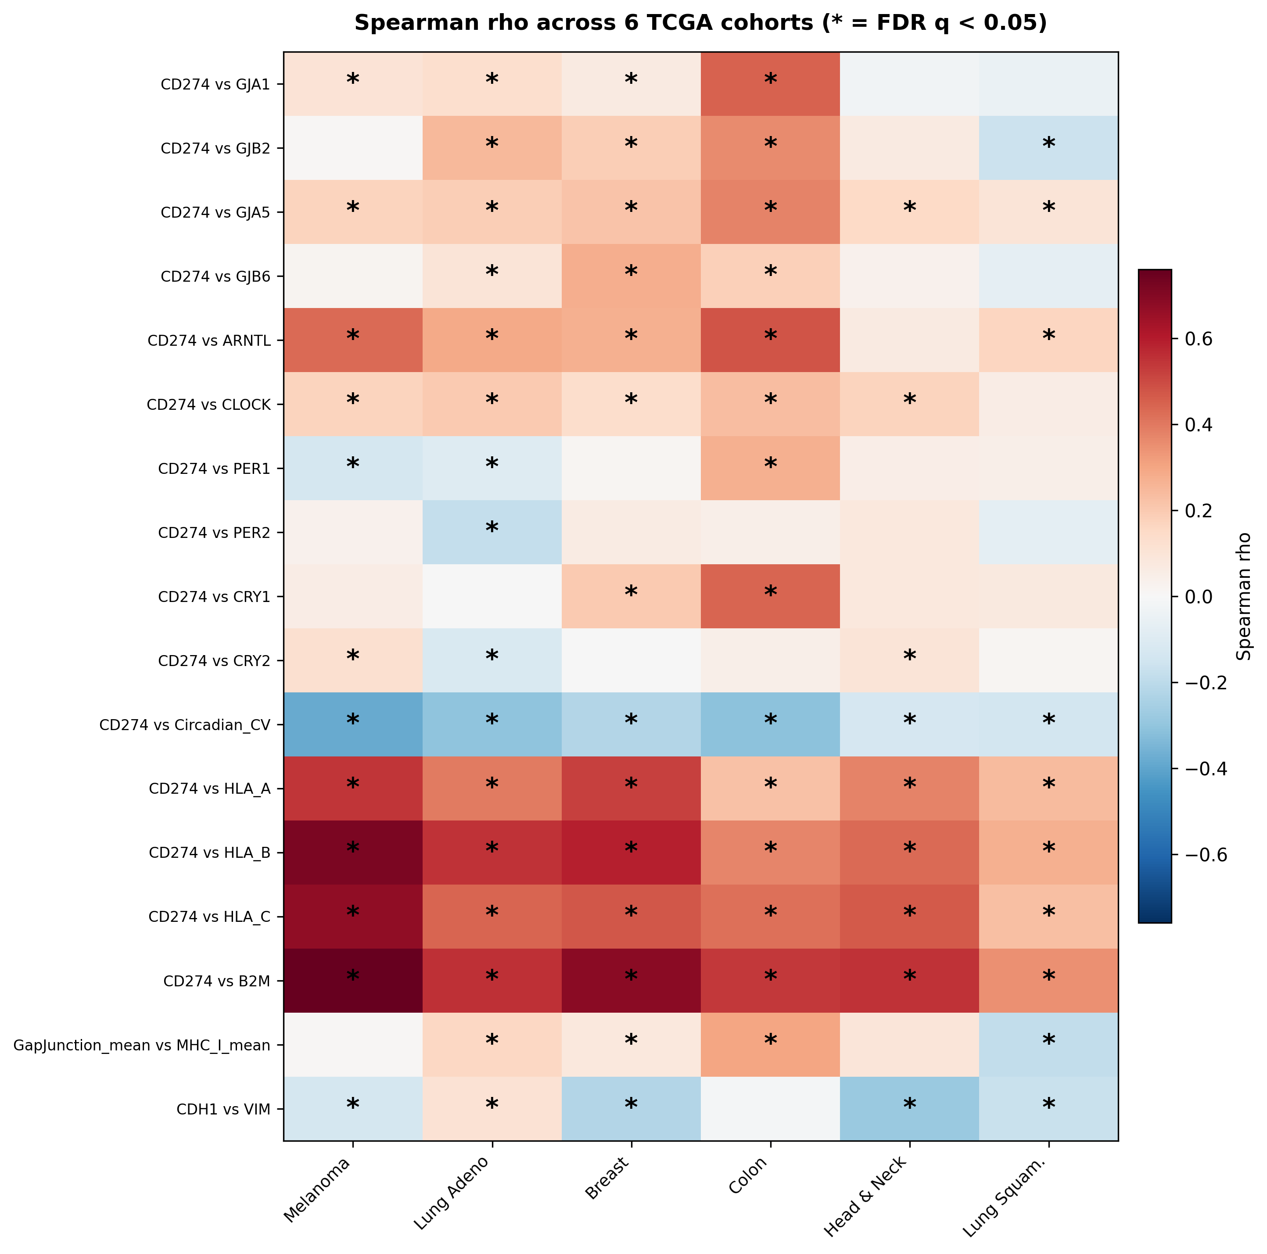

**Cross-cancer correlation structure.** Spearman correlations for key gene pairs across all six TCGA cohorts ( $n=3,611$ tumors). The circadian CV-PD-L1 negative coupling (top row) replicates in 6/6 cancer types. BMAL1 is positively associated with PD-L1; PER genes are negatively associated, consistent with clock restructuring, not uniform disruption.

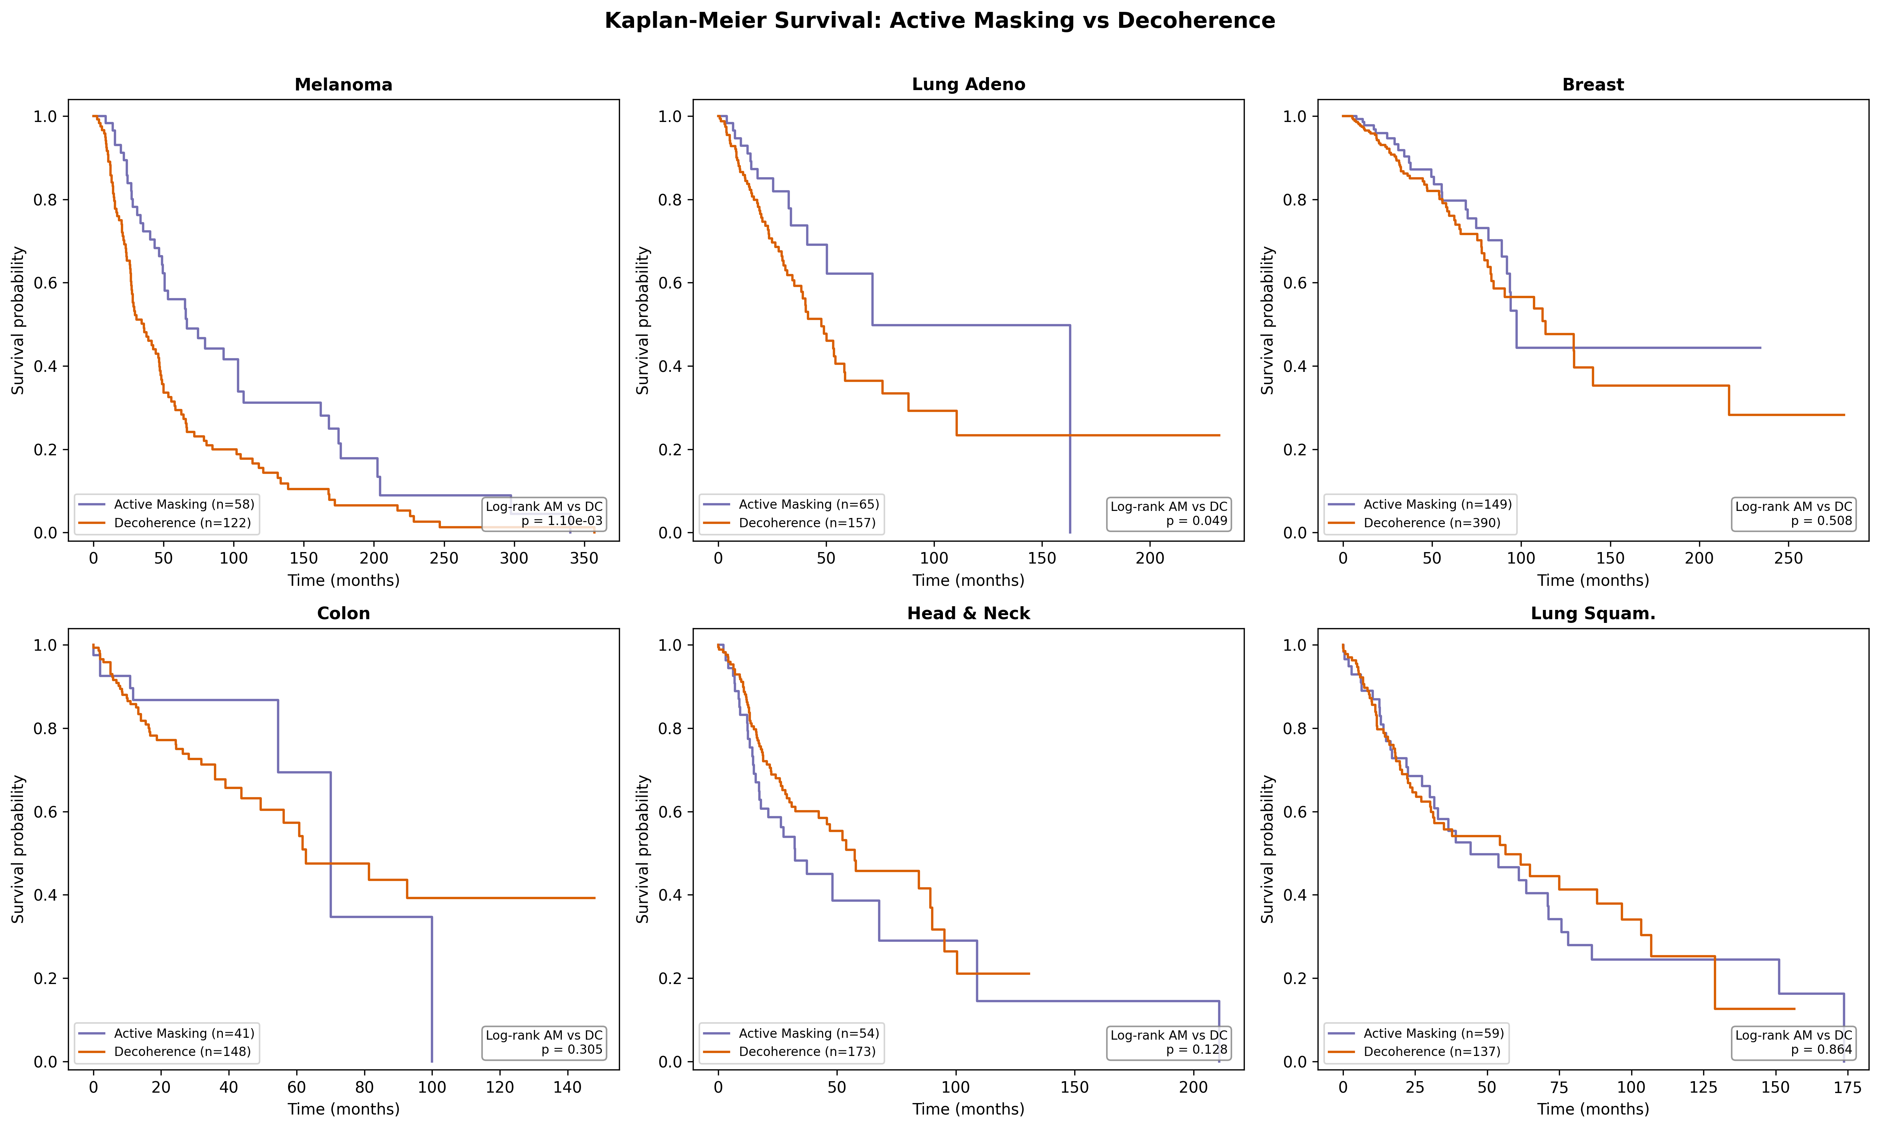

**Survival by boundary-failure subtype.** Kaplan-Meier curves for Active Masking vs. Decoherence across six TCGA cohorts. The survival association is melanoma-dominant: SKCM (log-rank $p=0.0011$, BH $q=0.0132$); LUAD is directionally similar but nominal ($p=0.049$, $q=0.294$); remaining cohorts are non-significant.

# Methods

## Data Sources and Cohorts

We analyzed bulk RNA-seq expression and clinical data from The Cancer Genome Atlas (TCGA), accessed through ISB Cancer Genomics Cloud BigQuery tables  (isb-cgc-bq.TCGA.RNAseq_hg38_gdc_r35). Six cohorts were included:

* TCGA-SKCM (melanoma): $n=472$ tumor, $n=1$ normal
* TCGA-LUAD (lung adenocarcinoma): $n=530$ tumor, $n=59$ normal
* TCGA-BRCA (breast): $n=1,113$ tumor, $n=113$ normal
* TCGA-COAD (colon): $n=473$ tumor, $n=41$ normal
* TCGA-HNSC (head/neck squamous cell carcinoma): $n=522$ tumor, $n=44$ normal
* TCGA-LUSC (lung squamous cell carcinoma): $n=501$ tumor, $n=51$ normal

Total: $n=3,611$ tumor samples; $n=3,920$ total including normals.

We extracted transcripts-per-million (TPM) values for 21 target genes across five functional categories: immune checkpoint (CD274/PD-L1, PDCD1LG2, PDCD1), MHC class I (HLA-A, HLA-B, HLA-C, B2M), gap junction (GJA1/Cx43, GJB2/Cx26, GJA5/Cx40, GJB6/Cx30), circadian clock (ARNTL/BMAL1, CLOCK, PER1, PER2, CRY1, CRY2), and differentiation markers (CDH1, VIM, MYC, TP53). Expression values were log $​_{2}$ (TPM $+$ 1) transformed. Repository script: experiments/tcga/tcga_extract_expanded.py.

## Circadian CV Metric

We defined a per-sample circadian coherence proxy as the coefficient of variation (CV) across six core clock genes (ARNTL, CLOCK, PER1, PER2, CRY1, CRY2). Lower CV indicates more uniform clock-gene expression within a sample. We use “coherent” descriptively to mean low cross-gene dispersion; we do not claim this implies functional rhythmicity or temporal phase alignment. Low CV could also reflect uniform dampening or mean-scaling effects in bulk RNA-seq. Because this is a within-sample cross-gene dispersion metric, it is interpreted as a transcriptional clock-structure proxy rather than a direct estimate of circadian dynamics. Time-series and single-cell assays would be required for temporal phase measurement.

#### Distinction from population-level metrics.

Our within-sample CV measures *cross-gene expression uniformity in a single tumor*: how similarly expressed the six clock genes are relative to each other within one sample. This differs fundamentally from the normalized coefficient of variation (nCV) introduced by Wu et al. , which measures *per-gene oscillation robustness across a population*: how variable one gene’s expression is across many patients, normalized against background variation. The two metrics answer complementary questions: nCV asks “does this gene oscillate robustly across the population?” while our CV asks “are clock genes co-expressed uniformly within this tumor?” To establish convergent validity, we computed an nCV-weighted per-sample score (a sample-level proxy derived from the Wu et al. population-level method; not a direct application of canonical nCV) on the same TCGA data. Our CV correlated positively with the nCV-weighted score in all six cohorts (Spearman $ρ=0.30-0.60$, all $p<0.003$), confirming that both metrics partially capture the same underlying clock-structure variation despite measuring different dimensions. Repository script: convergent_validity_ncv.py.

## Boundary-Failure Subtype Classification

Tumors were classified into boundary-failure subtypes (as defined in Section 1) based on expression of key genes:

* **Active Masking (AM):** high CD274 (PD-L1) + high ARNTL (BMAL1) + low PER1. Thresholds set at within-cohort median.
* **Temporal Decoherence (DC):** low CD274 + low B2M.
* **Mixed:** all remaining tumors.

Because ARNTL and PER1 are included in both the CV calculation and the AM definition, the CV contrast between subtypes is interpreted as internal-consistency evidence, not independent validation.

## Survival Analysis

Patient-level deduplication retained one tumor sample per case ( $n=3,089$ valid overall-survival cases). Kaplan-Meier survival curves were compared using log-rank tests. Benjamini-Hochberg (BH) correction was applied across all 12 pre-specified survival tests (6 AM-vs-DC + 6 circadian quartile, Q1 vs Q4). Multivariable Cox proportional hazards models included covariates: boundary mode, age, sex, and stage (categorical). Where available, microenvironment covariates from the TCGA immune landscape characterization  were added: purity, lymphoid/myeloid/leukocyte infiltration proxies, stromal fraction, IFN- $γ$ response, and TGF- $β$ response. RMST (area under the KM curve up to a time horizon $τ$) was computed as a PH-assumption-free alternative, with bootstrap 95% CIs ( $n=1,000$ resamples, seed=42). Repository scripts: tcga_survival.py, robustness_check.py, sensitivity_rmst.py.

## Sensitivity Analyses

#### Threshold sweep.

The AM/DC classification percentile was swept from 25th to 75th in steps of 5, with log-rank tests re-run at each threshold (sensitivity_threshold_sweep.py).

#### Immune residualization.

Circadian CV was regressed on five immune covariates (leukocyte fraction, lymphocyte infiltration, IFN- $γ$ response, tumor purity, stromal fraction) via OLS, and residuals were correlated with PD-L1 (sensitivity_immune_residualization.py).

#### Purity stratification.

Tumors were split into purity tertiles and correlations recomputed within each stratum.

#### Composite observability index.

An independent index was constructed from features *not* used in the AM/DC classification: MHC-I composite (mean log $​_{2}$ HLA-A, HLA-B, HLA-C;not B2M), gap junction composite (mean log $​_{2}$ GJA1, GJB2, GJA5, GJB6), and orthogonal circadian CV (CV of CLOCK, PER2, CRY1, CRY2;excluding ARNTL and PER1). Each component was $z$-scored within cohort and averaged with equal weights (composite_observability_index.py).

## External Validation

The circadian-checkpoint coupling was tested in three independent immunotherapy cohorts beyond TCGA:

* GSE91061 : nivolumab melanoma, $n=49$ pre-treatment, FPKM via Entrez ID mapping.
* GSE78220 : anti-PD-1 melanoma, $n=27$ baseline, FPKM from supplementary matrix.
* GSE115821 : anti-PD-1/anti-CTLA-4 melanoma (Auslander et al.), $n=37$, raw counts normalized to CPM then log $​_{2}$-transformed.

All three cohorts were processed independently using committed scripts (run_external_validation.py, external_validation_gse78220.py).

## Statistical Methods

The following methods were used across analyses: Spearman rank correlation (non-parametric), Benjamini-Hochberg FDR correction, Wilcoxon signed-rank test (paired tumor-normal), Mann-Whitney U test (unpaired group comparisons), Kruskal-Wallis H test (multi-group AM/DC/Mixed), Kaplan-Meier estimator with log-rank test, multivariable Cox proportional hazards regression, restricted mean survival time (RMST) with bootstrap CIs, OLS residualization for immune covariate adjustment, and Fisher exact test (external validation response comparison). All analyses were performed in Python (numpy, pandas, scipy; matplotlib for figures).

#### Evidence reporting convention.

To avoid over- or under-stating results, each endpoint is labeled as *FDR-significant* ($q<0.05$), *nominal/directional* (raw $p<0.05$ but $q≥0.05$), or *non-significant*. Nominal and non-significant findings are retained for transparency and hypothesis generation but are not interpreted as confirmatory evidence.

## Code and Data Availability

All data and code required to reproduce every result are available at: <https://github.com/MosesRahnama/circadian-checkpoint-cancer>. Extracted TCGA data (CSV), analysis scripts (Python), and all generated figures are committed to the repository. No GCP account or internet connection is required to reproduce any analysis from the committed files. Original data sources: ISB-CGC BigQuery (TCGA RNA-seq hg38 GDC r35), GEO GSE91061 .

# Results

## Circadian CV-PD-L1 Coupling Across Six Cancer Types

Circadian CV showed a significant negative correlation with PD-L1 expression in **all six cohorts** (100% replication rate, all FDR $q<0.05$):

* TCGA-SKCM: $ρ=-0.381$, $p=9.6×{10}^{-18}$, $n=472$
* TCGA-LUAD: $ρ=-0.303$, $p=1.1×{10}^{-12}$, $n=530$
* TCGA-BRCA: $ρ=-0.222$, $n=1,113$
* TCGA-COAD: $ρ=-0.312$, $n=473$
* TCGA-HNSC: $ρ=-0.125$, $n=522$
* TCGA-LUSC: $ρ=-0.142$, $n=501$

Higher PD-L1 expression tracks *lower* circadian CV (more coherent clock expression) across all six cancer types. Among individual clock genes, ARNTL (BMAL1) showed the strongest positive association with PD-L1 (SKCM: $ρ=+0.428$, $p=1.9×{10}^{-22}$; LUAD: $ρ=+0.287$, $p=1.6×{10}^{-11}$), while PER1 was negatively correlated in both cohorts (SKCM: $ρ=-0.136$, $p=0.003$; LUAD: $ρ=-0.099$, $p=0.023$). The divergent directions within the clock network (BMAL1/CLOCK positively associated and PER genes negatively associated) suggest that PD-L1-high tumors exhibit *restructured* rather than uniformly disrupted circadian programs.

A plausible interpretation is an immune-hot state: interferon- $γ$ signaling from infiltrating T cells can co-activate PD-L1 and BMAL1-responsive programs , producing an inflamed but checkpoint-protected microenvironment. Replication across six tissue contexts supports generalizability of direction, while effect magnitude is heterogeneous (weaker in HNSC/LUSC than in SKCM/LUAD). The full cross-cancer correlation structure is shown in Figure 2.

Primary Spearman correlations for target genes in discovery cohorts. All values are log $​_{2}$ (TPM $+$ 1)-transformed. Data source: ISB-CGC BigQuery (isb-cgc-bq.TCGA.RNAseq_hg38_gdc_r35).

|  |  |  |  |  |  |
| --- | --- | --- | --- | --- | --- |
| **Comparison** | **Category** | **TCGA-SKCM** | | **TCGA-LUAD** | |
|  |  | $$ρ$$ | $$p$$ | $$ρ$$ | $$p$$ |
| CD274 vs Circadian CV | Coherence | $$-0.381$$ | $$9.6​×​{10}^{-18}$$ | $$-0.303$$ | $$1.1​×​{10}^{-12}$$ |
| CD274 vs ARNTL | Clock | $$+0.428$$ | $$1.9​×​{10}^{-22}$$ | $$+0.287$$ | $$1.6​×​{10}^{-11}$$ |
| CD274 vs PER1 | Clock | $$-0.136$$ | $$3.1​×​{10}^{-3}$$ | $$-0.099$$ | $$2.3​×​{10}^{-2}$$ |
| CD274 vs B2M | MHC-I | $$+0.760$$ | $$7.0​×​{10}^{-90}$$ | $$+0.555$$ | $$3.7​×​{10}^{-44}$$ |
| CD274 vs GJA1 | Gap jcn. | $$+0.105$$ | $$2.3​×​{10}^{-2}$$ | $$+0.125$$ | $$3.9​×​{10}^{-3}$$ |

## PD-L1 and MHC Class I Co-regulation

PD-L1 expression was strongly positively correlated with MHC class I components: B2M (SKCM $ρ=+0.760$, $p=7.0×{10}^{-90}$; LUAD $ρ=+0.555$, $p=3.7×{10}^{-44}$) and HLA-B (SKCM $ρ=+0.717$, $p=1.3×{10}^{-75}$; LUAD $ρ=+0.547$, $p=1.2×{10}^{-42}$). This co-upregulation is consistent with shared IFN- $γ$ transcriptional regulation . In boundary terms, this identifies a specific failure mode: the antigen-presentation channel (MHC-I) is intact, but the clearance decision is overridden by checkpoint engagement (PD-L1). The boundary is visible but *vetoed*.

## Gap Junction Expression (Null/Weak Result)

Connexin transcript levels showed weak positive correlations with PD-L1 (GJA1/Cx43: SKCM $ρ=+0.105$, $p=0.023$; LUAD $ρ=+0.125$, $p=0.004$), rather than the predicted inverse relationship. Gap junction composite expression was uncorrelated with MHC-I composite in SKCM ($ρ=+0.006$, $p=0.89$) and weakly positive in LUAD ($ρ=+0.155$, $p=0.0003$). These transcript-level associations are treated as non-confirmatory, consistent with known limitations of bulk RNA-seq for connexins : functional gap-junction intercellular communication depends on protein localization, phosphorylation state, and channel gating rather than transcript abundance.

## Tumor vs. Matched Normal Circadian CV

Contrary to the naive “broken clock” prediction, tumors showed **lower** circadian CV than matched normals in four of five cancer types with sufficient normal tissue representation (SKCM excluded due to $n=1$ normal):

* TCGA-LUAD: $p=2.28×{10}^{-6}$
* TCGA-BRCA: $p=5.13×{10}^{-9}$
* TCGA-HNSC: $p=7.0×{10}^{-7}$
* TCGA-LUSC: $p=8.6×{10}^{-7}$
* TCGA-COAD: not significant

This supports a “locked, not broken” transcriptional restructuring interpretation: the clock-gene program appears co-opted rather than simply disrupted. Because CV is a within-sample cross-gene dispersion proxy from bulk RNA-seq, it does not establish temporal phase coherence or rhythmicity; time-series and single-cell assays are required for that.

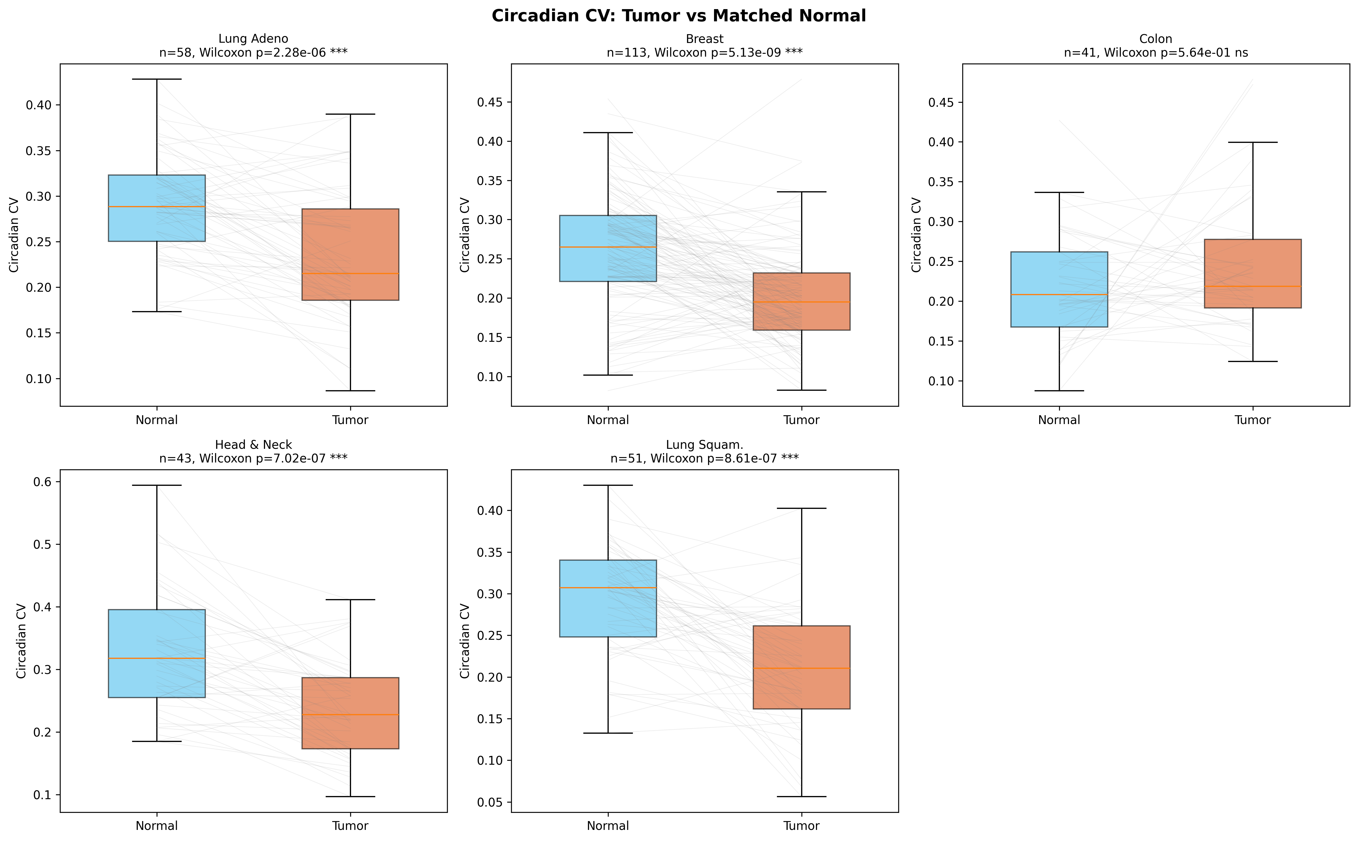

**Circadian CV in tumor vs. matched normal tissue** across five TCGA cancer types. Tumors show significantly lower CV (more uniform clock-gene expression) than matched normals in 4/5 cancer types, supporting a transcript-level “locked, not broken” restructuring signature.

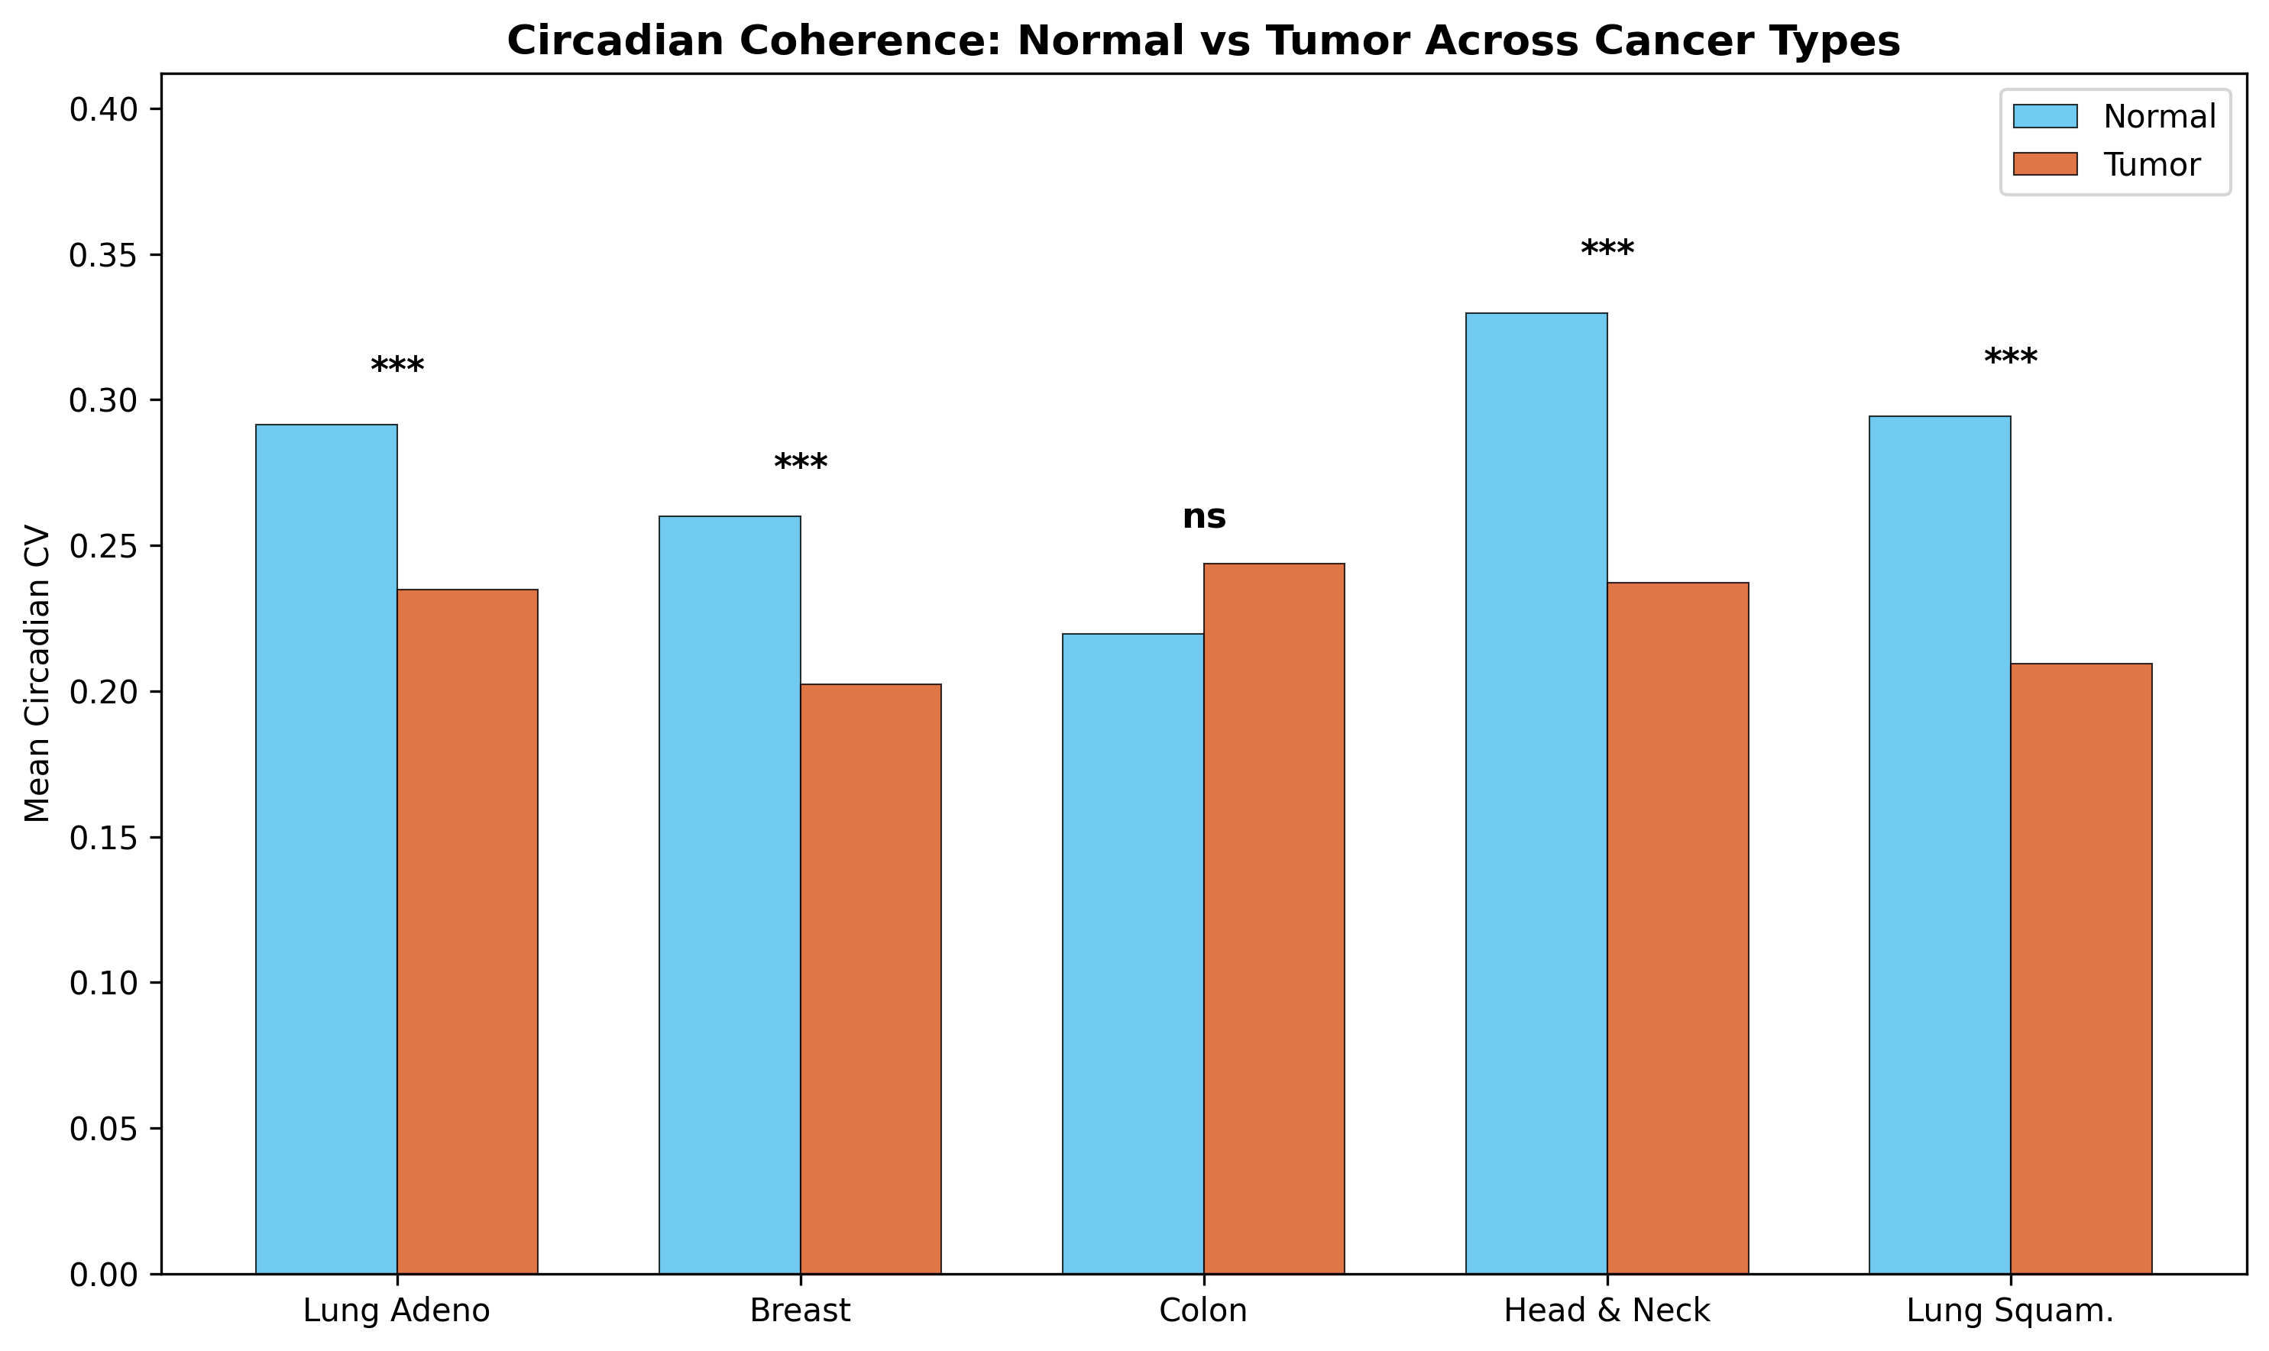

**Cohort-level summary** of tumor-minus-normal circadian CV shifts. Four cohorts show negative deltas (tumor lower than normal), while COAD is near-neutral/non-significant.

## Active Masking vs. Decoherence Classification

Active Masking tumors showed significantly **lower** circadian CV than Decoherence tumors in **all six cancer types** (Kruskal-Wallis FDR $q<{10}^{-9}$; pairwise AM-vs-DC Mann-Whitney FDR $q<{10}^{-4}$). Although AM is defined by divergent BMAL1/PER1 levels relative to the population median, this state corresponds to a convergence of absolute expression levels within individual tumors, resulting in higher coherence (lower CV) compared to the disjointed expression profiles of Decoherence tumors. This is consistent with the two boundary-failure modes having distinct circadian architectures: Active Masking tumors maintain tight clock coordination, while Decoherence tumors show variable and disordered circadian programs.

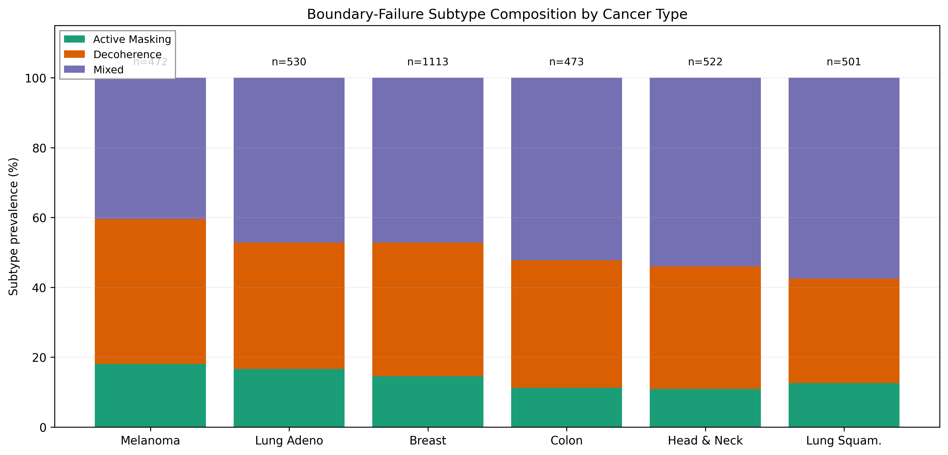

**Boundary-failure subtype composition** across six TCGA cohorts. Active Masking, Decoherence, and Mixed classes are all present in each cohort.

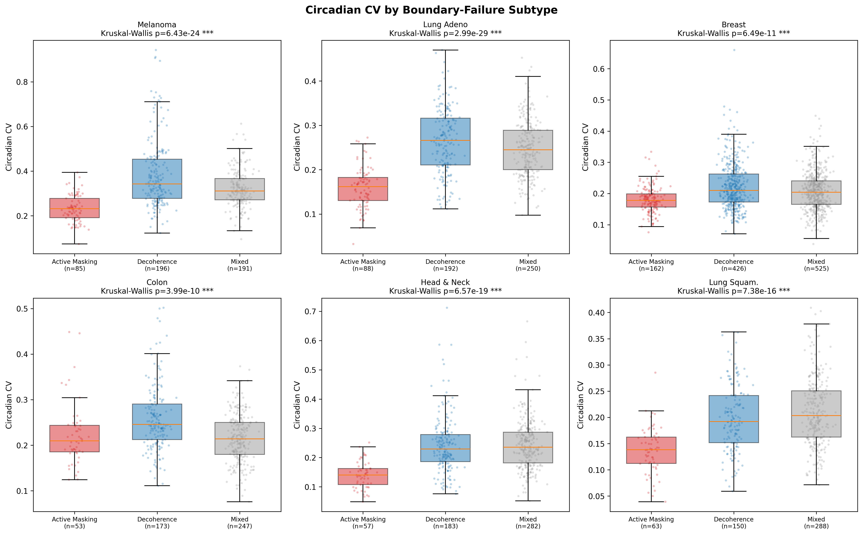

**Circadian CV by boundary-failure subtype** across six TCGA cancer types. AM tumors show consistently lower CV than DC tumors in all six cancer types (Kruskal-Wallis FDR $q<{10}^{-9}$; pairwise AM-vs-DC Mann-Whitney FDR $q<{10}^{-4}$). Because subtype definitions include ARNTL/PER1, this is interpreted as internal-consistency evidence.

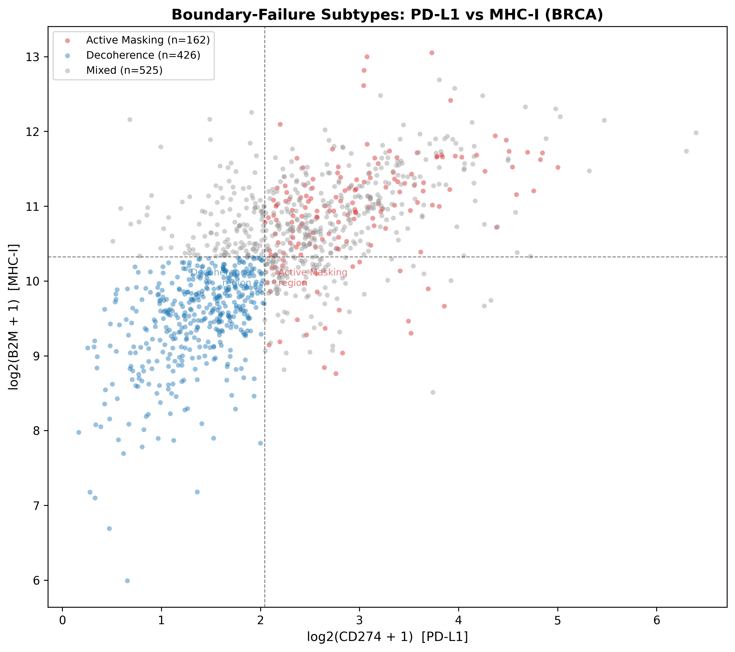

**Checkpoint-clock boundary space** colored by subtype classification. Active Masking and Decoherence occupy separable regions defined by PD-L1, ARNTL, PER1, and B2M threshold logic.

## Survival Analysis

Active Masking tumors showed better overall survival than Decoherence tumors in the following pattern:

* TCGA-SKCM: log-rank $p=0.0011$, BH $q=0.0132$ (**FDR-significant**; Active Masking survives longer)
* TCGA-LUAD: log-rank $p=0.049$, BH $q=0.294$ (same direction, nominal only)
* TCGA-BRCA, TCGA-COAD, TCGA-HNSC, TCGA-LUSC: not significant

Across the 12 pre-specified survival contrasts (6 AM-vs-DC and 6 circadian quartile tests), BH correction yields 1 FDR-significant endpoint (SKCM AM-vs-DC), 1 nominal endpoint (LUAD AM-vs-DC), and 10 non-significant endpoints.

#### Threshold sensitivity.

The SKCM signal is significant ($p<0.05$) from the 25th to the 65th percentile (9/11 thresholds), with the strongest signal at the 35th-40th percentile ($p=0.0005$). The median is therefore a conservative choice, not a cherry-picked threshold. LUAD reaches nominal significance only at the median.

Quartile-based circadian CV alone did not predict survival in any of the six cancer types, suggesting that boundary-failure *mode* may matter more than coherence level per se (Figure 3).

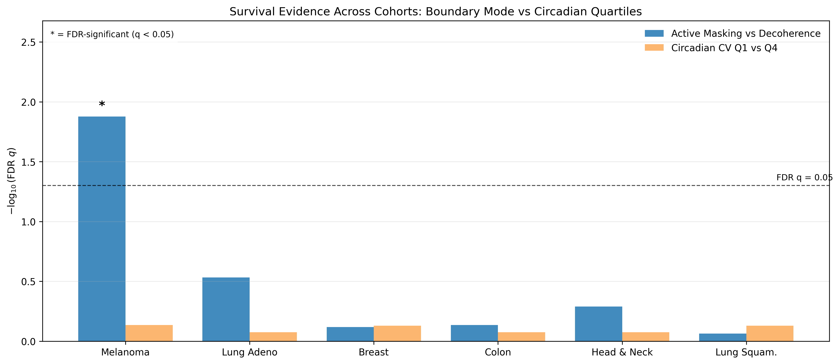

**Cross-cohort FDR-adjusted survival evidence summary.** Grouped bars show $-\log_{10}(q)$ for AM-vs-DC and circadian-CV quartile tests. Asterisks denote FDR-significant tests ($q<0.05$).

## Robustness to Clinical Covariates

In multivariable, microenvironment-adjusted Cox models:

* **Adjusted boundary-mode effect:** SKCM HR $=0.507$, $p=0.0286$, BH $q=0.0686$ (nominal); LUAD HR $=0.288$, $p=0.0114$, BH $q=0.0454$ (FDR-significant).
* **Adds beyond PD-L1/B2M:** After adding continuous PD-L1 and B2M, boundary mode remained directionally protective but no longer FDR-significant in either cohort (SKCM HR $=0.562$, $p=0.131$; LUAD HR $=0.273$, $p=0.0343$).
* **PD-L1 $×$ clock interaction:** Significant in SKCM (HR $=0.217$, $p=0.00749$, BH $q=0.0454$), supporting non-additive coupling between checkpoint engagement and clock state. Not significant in LUAD ($p=0.240$).
* **Partial-correlation controls:** Circadian CV-PD-L1 association remained negative after covariate adjustment (SKCM partial $r=-0.238$, $p=4.29×{10}^{-5}$; LUAD partial $r=-0.144$, $p=0.00658$).

#### RMST.

Because PH violations are prevalent, RMST was computed as a PH-assumption-free alternative:

* SKCM ( $τ=60$ months): $+11.4$ months (95% CI: $5.3-16.8$); ( $τ=120$ months): $+24.2$ months (95% CI: $10.8-36.8$). Significant at all four horizons.
* LUAD ( $τ=60$ months): $+7.8$ months (95% CI: $1.3-14.2$). Significant up to $τ=84$ months; 120-month CI crosses zero.

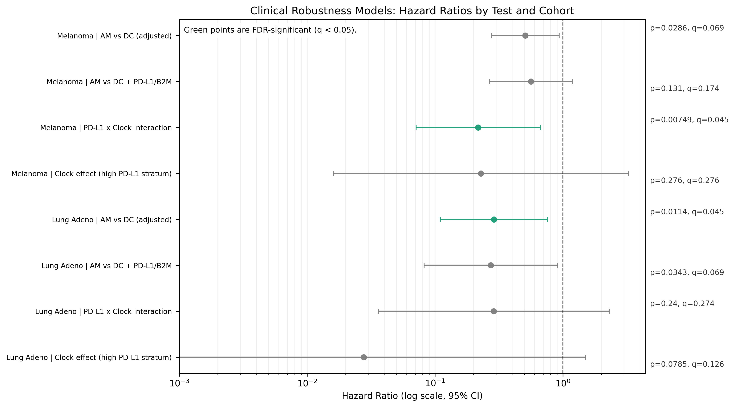

**Hazard-ratio forest plot** for primary robustness models. Green markers denote FDR-significant tests. Two tests meet FDR significance (LUAD adjusted AM-vs-DC and SKCM PD-L1 $×$ clock interaction).

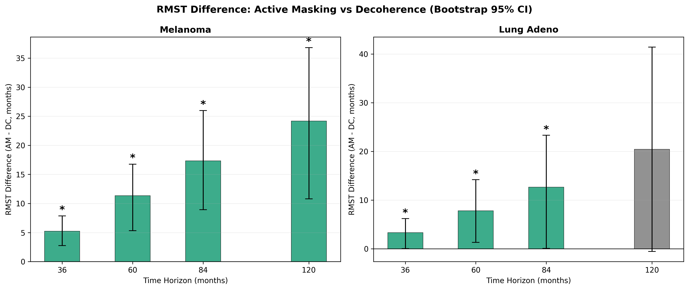

**RMST difference** (Active Masking minus Decoherence, in months) at four time horizons. Bootstrap 95% CIs ($n=1,000$, seed=42). Green bars: CI excludes zero.

## Stage-Stratified Analysis

Circadian CV was largely stage-stable: 11/12 circadian-stage tests were non-significant after BH correction within the pre-specified stage-endpoint family, with one near-threshold HNSC Spearman trend ($q=0.04998$, $ρ=0.112$; technically FDR-significant but small in magnitude; under the broader global FDR across all 244 tests in master_fdr_results.csv, this becomes non-significant at $q=0.19$). This pattern is compatible with early-established, persistent circadian restructuring rather than strong late-stage accumulation.

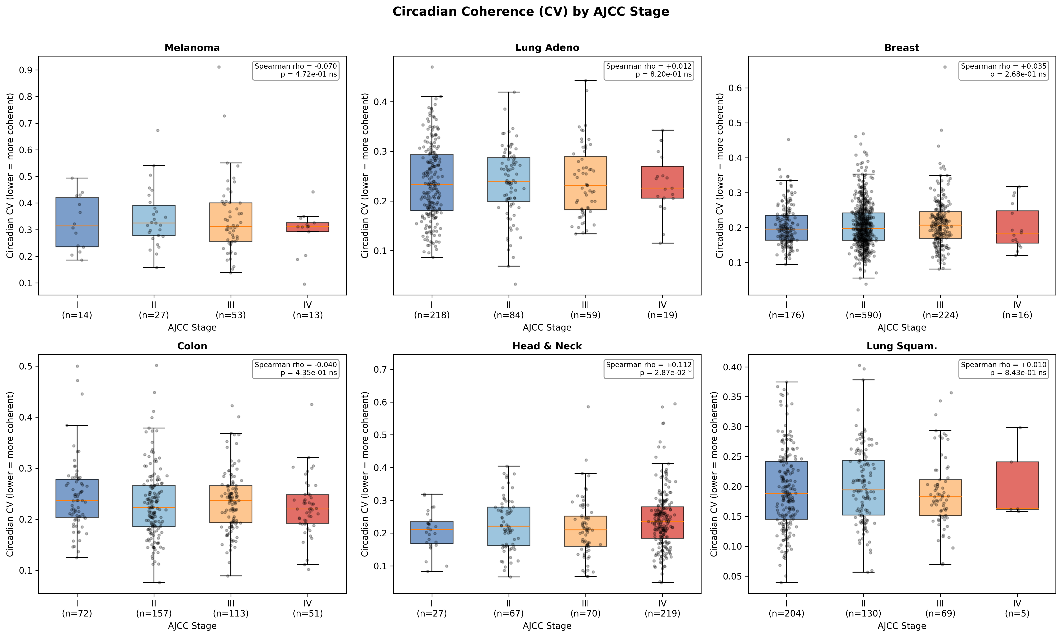

**Circadian CV by pathologic tumor stage** across six TCGA cancer types. Circadian-stage association is largely absent after global FDR correction, consistent with stage-stable circadian restructuring.

## Stromal Confound Sensitivity

#### Immune-fraction residualization.

Immune covariates explained only 0.7-13.8% of circadian CV variance ($R^{2}$). After removing these effects, the residual CV-PD-L1 correlation remained significant in all four cohorts tested: SKCM (residual $ρ=-0.141$, $p<0.01$), LUAD ($ρ=-0.159$, $p<0.001$), BRCA ($ρ=-0.173$, $p<0.001$), and HNSC ($ρ=-0.126$, $p<0.01$).

#### Purity-stratified replication.

The negative correlation persisted within all three purity tertiles for SKCM (strongest in low purity: $ρ=-0.480$), LUAD, and BRCA (9/9 tertile-level tests significant). HNSC tertiles were individually non-significant, consistent with its smallest raw effect size.

These analyses demonstrate that the circadian-checkpoint coupling has a component beyond bulk immune-fraction mixing, though the stronger signal in low-purity (immune-rich) samples suggests that tumor-immune resonance may amplify the effect.

#### Mean-expression control.

Because $\text{CV}=σ/μ$, low CV could reflect high mean clock-gene expression rather than structural coherence per se. To rule out this abundance artifact, we computed the partial correlation between CV and PD-L1 after residualizing both on mean log $​_{2}$ clock-gene expression. The association remained significant in all six cohorts: SKCM ($ρ_{\text{partial}}=-0.301$, $p=0.002$), LUAD ($-0.303$, $p=1.1×{10}^{-12}$), BRCA ($-0.197$, $p=4.3×{10}^{-11}$), COAD ($-0.171$, $p=2.0×{10}^{-4}$), HNSC ($-0.105$, $p=0.016$), LUSC ($-0.144$, $p=0.001$). The CV-PD-L1 coupling is therefore not an artifact of mean expression level.

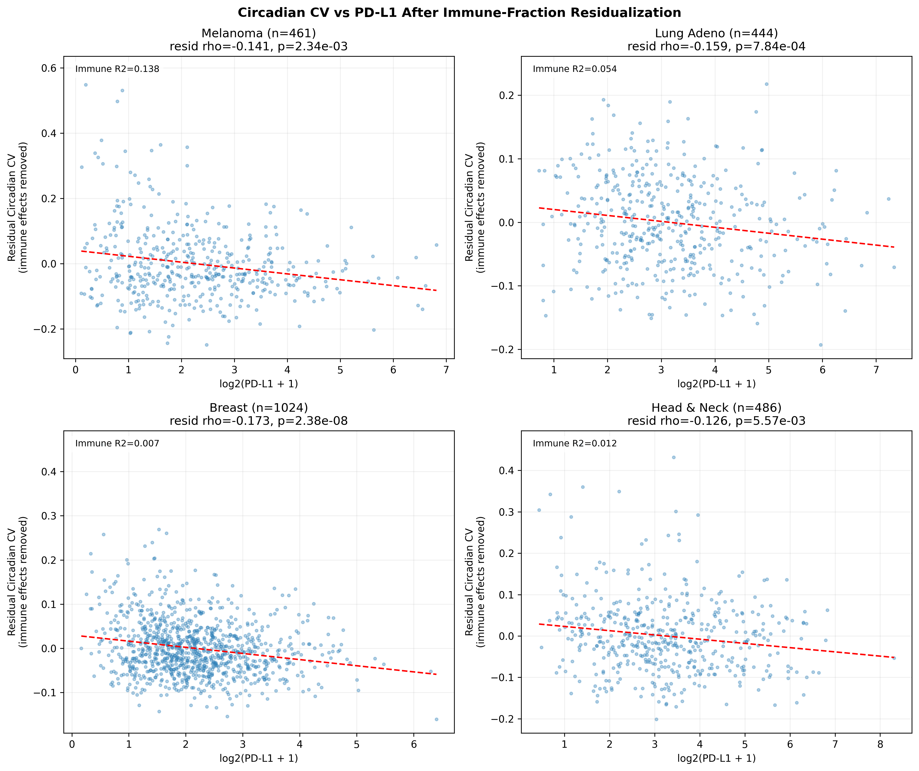

**Circadian CV vs. PD-L1 after immune-fraction residualization** in four TCGA cohorts. Immune covariates explain $R^{2}=0.007-0.138$ of CV variance; the residual correlation remains significant in all four cohorts.

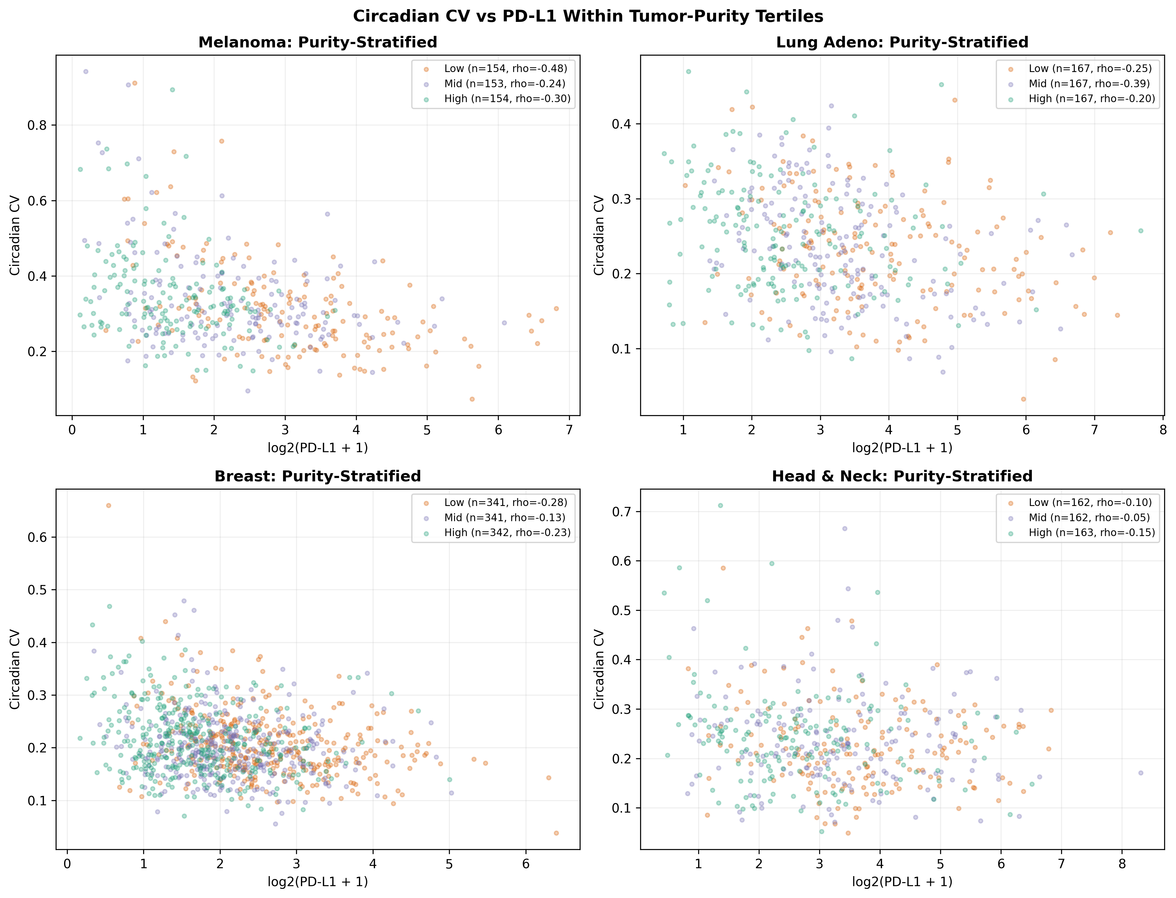

**Purity-stratified correlations.** The negative CV-PD-L1 correlation persists in all three strata for SKCM, LUAD, and BRCA, arguing against a pure stromal-mixing explanation.

## Composite Observability Index

The independently constructed observability index (using features orthogonal to AM/DC classification) separates AM from DC with $p=1.7×{10}^{-10}$ (SKCM) and $p=1.5×{10}^{-20}$ (LUAD), confirming that boundary-failure subtypes differ on features independent of their definition. The index correlates with PD-L1 at $ρ=+0.482$ (SKCM) and $+0.539$ (LUAD). Median-split survival shows a directional advantage for high-observability tumors ( $p=0.063$ SKCM, $p=0.083$ LUAD), not FDR-significant, but consistent with the framework using deliberately weaker, orthogonal features.

## External Replication

The circadian CV-PD-L1 coupling was tested in three independent immunotherapy cohorts beyond TCGA:

* **GSE91061** (Riaz et al. 2017 ; nivolumab melanoma, $n=49$ pre-treatment): $ρ=-0.283$, $p=0.049$ (nominally significant).
* **GSE78220** (Hugo et al. 2016 ; anti-PD-1 melanoma, $n=27$ baseline): $ρ=-0.283$, $p=0.152$ (same direction, underpowered).
* **GSE115821** (Auslander et al. ; anti-PD-1/anti-CTLA-4 melanoma, $n=37$): $ρ=-0.222$, $p=0.187$ (same direction, underpowered).

The CV-PD-L1 correlation is directionally negative in all 9 cohorts tested (6 TCGA + 3 external), with 7/9 reaching nominal or FDR significance. The three external cohorts are individually underpowered ($n=27-49$), and only GSE91061 reaches nominal significance ($p=0.049$); directional consistency across 9 independent datasets spanning 3 platforms and multiple treatment contexts is supportive but not confirmatory. All three external cohorts are melanoma immunotherapy; non-melanoma external validation remains a priority for future work.

In GSE91061, AM-vs-DC response rate comparison (Fisher exact $p=1.0$; $n_{\text{AM}}=10$) is underpowered for subtype-level response testing and is reported as descriptive only.

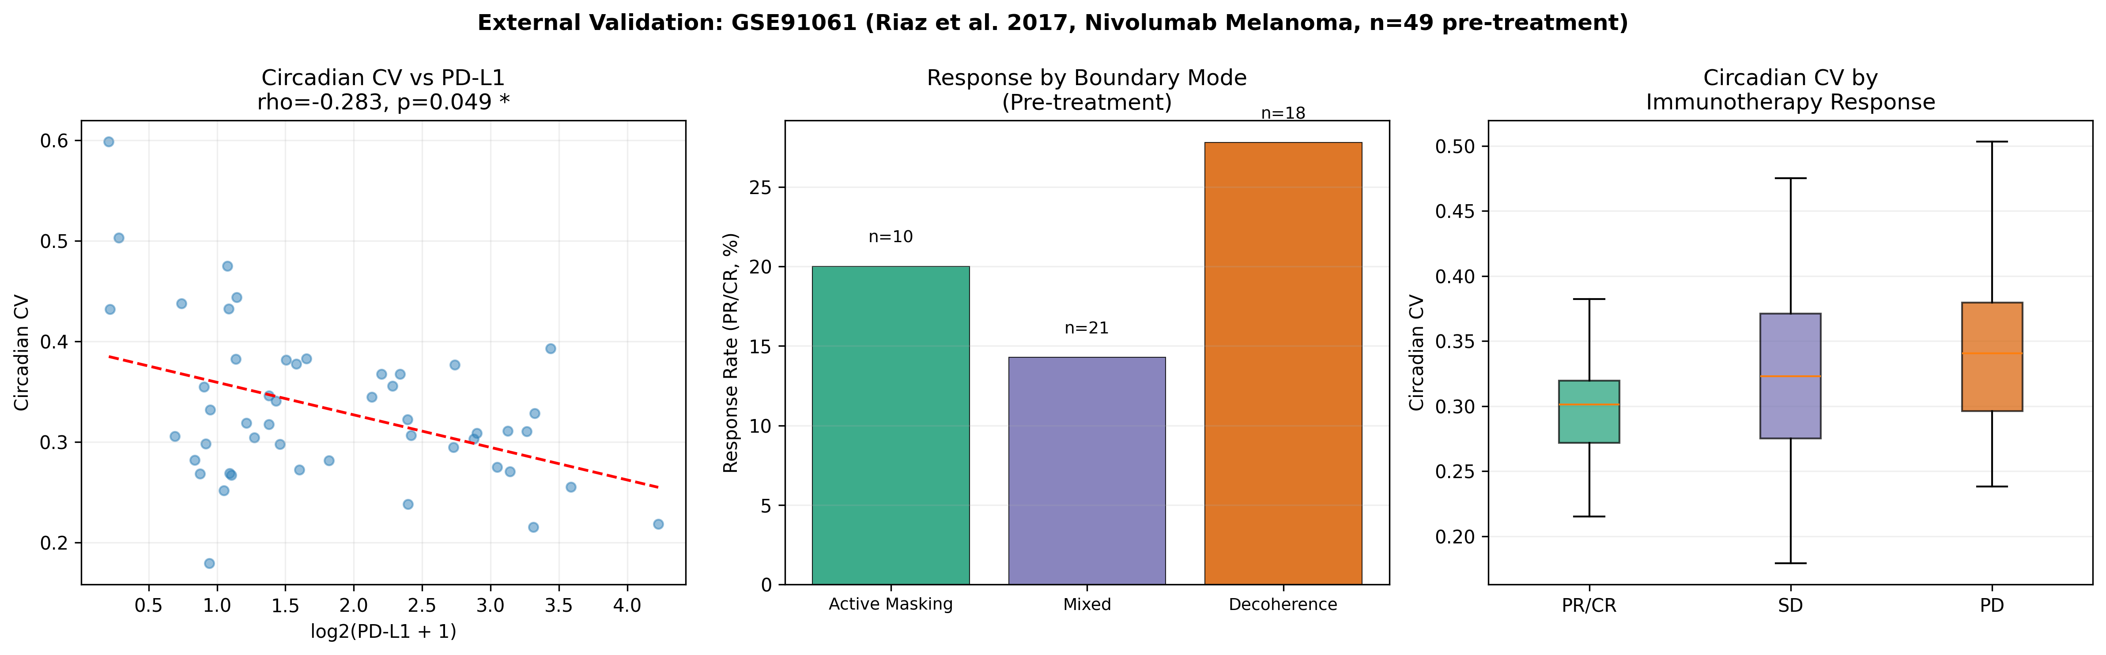

**External validation in GSE91061** (Riaz et al., nivolumab melanoma, $n=49$ pre-treatment). Left: circadian CV vs. PD-L1 replicates the TCGA negative correlation ($ρ=-0.283$, $p=0.049$). Center: immunotherapy response rate by boundary-failure subtype (underpowered). Right: circadian CV by RECIST response category. Two additional external cohorts (GSE78220, GSE115821) replicate the negative direction; see text.

## Incremental Value Beyond Immune Subtype

To test whether the circadian-checkpoint coupling is simply a relabeling of known immune phenotypes, we benchmarked against the Thorsson et al.  six-class immune subtype framework (C1-C6). AM tumors are enriched in C2 (IFN- $γ$ dominant; 53.4% of AM vs. 19.1% of DC; $χ^{2}=363.8$, $p=1.0×{10}^{-73}$), confirming that AM partially overlaps with the immune-hot phenotype. However, the CV-PD-L1 negative correlation **persists within each immune subtype**: C1 ($ρ=-0.299$, $p=4.2×{10}^{-27}$), C2 ($ρ=-0.178$, $p=3.7×{10}^{-10}$), C3 ($ρ=-0.098$, $p=0.047$), and C4 ($ρ=-0.210$, $p=0.009$); only C6 ($n=93$) was non-significant. In multivariable models predicting PD-L1 expression, circadian CV added significant incremental variance ($ΔR^{2}$) beyond immune subtype in all four cohorts tested: SKCM ($ΔR^{2}=0.100$, $p=1.3×{10}^{-4}$), LUAD ($ΔR^{2}=0.072$, $p=8.5×{10}^{-10}$), BRCA ($ΔR^{2}=0.058$, $p=1.1×{10}^{-16}$), HNSC ($ΔR^{2}=0.028$, $p=8.5×{10}^{-5}$). These results demonstrate that the circadian dimension captures information about PD-L1 engagement not explained by immune phenotype alone.

As additional convergent validity, a per-sample Clock Correlation Distance (CCD) proxy ;methodologically independent of both our CV and Wu et al.’s nCV;replicated the negative PD-L1 coupling in 4/6 cohorts (SKCM $ρ=-0.360$, $p=1.9×{10}^{-4}$; LUAD $ρ=-0.200$, $p=4.0×{10}^{-6}$; HNSC $ρ=-0.113$, $p=0.010$; LUSC $ρ=-0.162$, $p=3.4×{10}^{-4}$), providing a third established clock metric that independently supports the coupling. Repository script: thorsson_benchmarking.py.

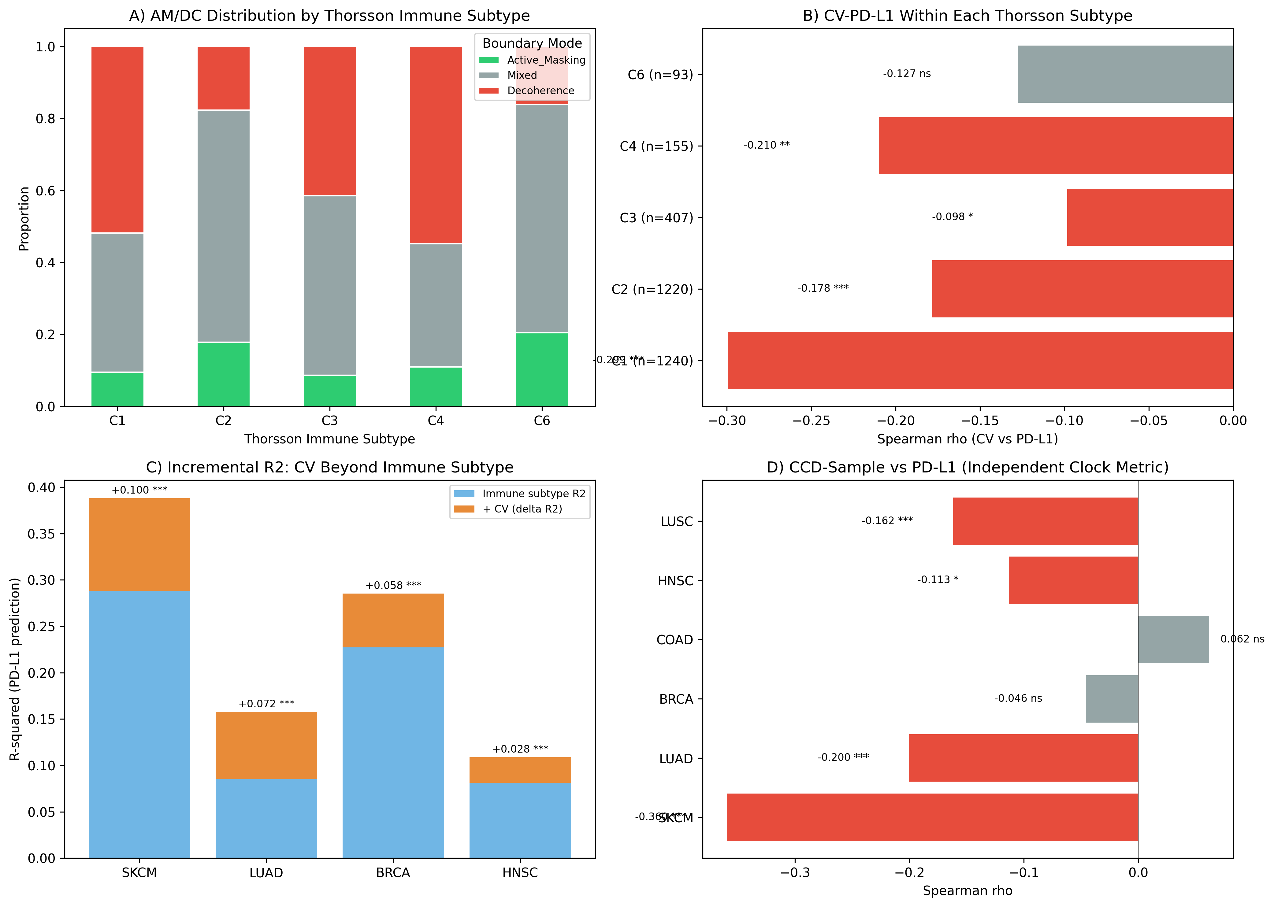

**Incremental value beyond immune subtype.** (A) AM/DC distribution across Thorsson immune subtypes: AM is enriched in C2 but not exclusive to it. (B) CV-PD-L1 correlation persists within each immune subtype (4/5 significant). (C) Circadian CV adds significant $ΔR^{2}$ beyond immune subtype for PD-L1 prediction in all 4 cohorts. (D) An independent CCD-based clock metric replicates the negative PD-L1 coupling in 4/6 cohorts.

## Evidence Summary

**Pre-specified endpoint evidence audit.** All pre-specified endpoint families: 12 survival tests (BH across all survival tests), 8 primary robustness Cox tests (BH across primary robustness tests), and 12 circadian stage tests (global BH correction). Categories: FDR-significant ($q<0.05$), Nominal ( $p<0.05$ with $q≥0.05$), and Non-significant.

| Family | Cohort | Endpoint | $$p$$ | $$q$$ | Category |
| --- | --- | --- | --- | --- | --- |
| Survival | SKCM | AM vs DC | $$0.0011$$ | $$0.0132$$ | FDR-significant |
| Survival | LUAD | AM vs DC | $$0.0489$$ | $$0.2937$$ | Nominal |
| Survival | BRCA | AM vs DC | $$0.5084$$ | $$0.7627$$ | Non-significant |
| Survival | COAD | AM vs DC | $$0.3050$$ | $$0.7319$$ | Non-significant |
| Survival | HNSC | AM vs DC | $$0.1283$$ | $$0.5133$$ | Non-significant |
| Survival | LUSC | AM vs DC | $$0.8641$$ | $$0.8641$$ | Non-significant |
| Survival | SKCM | Q1 vs Q4 | $$0.2545$$ | $$0.7319$$ | Non-significant |
| Survival | LUAD | Q1 vs Q4 | $$0.7698$$ | $$0.8397$$ | Non-significant |
| Survival | BRCA | Q1 vs Q4 | $$0.3822$$ | $$0.7414$$ | Non-significant |
| Survival | COAD | Q1 vs Q4 | $$0.7102$$ | $$0.8397$$ | Non-significant |
| Survival | HNSC | Q1 vs Q4 | $$0.7599$$ | $$0.8397$$ | Non-significant |
| Survival | LUSC | Q1 vs Q4 | $$0.4325$$ | $$0.7414$$ | Non-significant |
| Robustness | LUAD | AM vs DC (adj.) | $$0.0114$$ | $$0.0454$$ | FDR-significant |
| Robustness | SKCM | PD-L1 $×$ Clock | $$0.0075$$ | $$0.0454$$ | FDR-significant |
| Robustness | SKCM | AM vs DC (adj.) | $$0.0286$$ | $$0.0686$$ | Nominal |
| Robustness | LUAD | AM vs DC + PD-L1/B2M | $$0.0343$$ | $$0.0686$$ | Nominal |
| Robustness | LUAD | Clock (high PD-L1) | $$0.0785$$ | $$0.1257$$ | Non-significant |
| Robustness | SKCM | AM vs DC + PD-L1/B2M | $$0.1305$$ | $$0.1740$$ | Non-significant |
| Robustness | LUAD | PD-L1 $×$ Clock | $$0.2401$$ | $$0.2744$$ | Non-significant |
| Robustness | SKCM | Clock (high PD-L1) | $$0.2760$$ | $$0.2760$$ | Non-significant |
| Stage | HNSC | Spearman trend | $$0.0287$$ | $$0.0500$$ | FDR-significant |
| Stage | All others | All tests | - | $$>0.08$$ | Non-significant |

Across these 32 pre-specified endpoints, 4 are FDR-significant, 3 are nominal, and 25 are non-significant.

# Discussion

## Principal Findings

Circadian-checkpoint coupling replicates across 6/6 TCGA cohorts and is directionally consistent in 3/3 external melanoma immunotherapy cohorts (9/9 negative direction total; 7/9 nominally or FDR-significant). Tumors show restructured (“locked”) clocks, not broken ones: circadian CV is lower in tumors than in matched normals in 4/5 cancer types. Two boundary-failure modes exist with distinct survival profiles in melanoma: Active Masking (high PD-L1, locked clock, better survival) and Temporal Decoherence (low PD-L1, low B2M, worse survival).

## Relationship to Prior Work

The AM/DC distinction maps onto the cancer immunoediting framework  as a subdivision of the Escape phase. Active Masking corresponds to a specific Escape mechanism: the tumor remains antigen-visible but vetoes clearance via checkpoint engagement. Decoherence represents a distinct Escape route: loss of antigen presentation renders the tumor effectively invisible. We emphasize that AM and DC represent named endpoints of a continuous expression space, not discrete biological entities; tumors occupy a spectrum, and the median-split classification discretizes this for tractability. The survival signal is primarily a melanoma finding (SKCM: FDR-significant) with supporting evidence in lung adenocarcinoma (LUAD: nominal); the remaining four cohorts are non-significant. Prospective validation in immunotherapy cohorts with response endpoints is needed to determine whether the AM/DC distinction has clinical utility beyond observational survival association.

The PD-L1-MHC-I co-upregulation is consistent with the immune landscape characterization : interferon- $γ$ from infiltrating T cells co-activates PD-L1 and MHC-I, producing an immune-hot but checkpoint-protected microenvironment. The AM subtype captures this biology. Notably, IFN- $γ$ signaling also provides a direct mechanistic explanation for the AM clock signature: IFN- $γ$ suppresses PER1 expression  and can activate BMAL1 via RORC , predicting exactly the high-PD-L1/high-BMAL1/low-PER1 pattern that defines Active Masking. The AM phenotype may therefore be a predictable downstream consequence of chronic IFN- $γ$ signaling rather than an independent clock program.

The circadian dimension adds a distinct layer: clock-gene structure covaries with checkpoint state across six tissue contexts. Recent mechanistic work provides direct molecular links for this coupling: RORA suppresses PD-L1 via HDAC3 , CLOCK drives PD-L1 expression through NF- $κ$ B p65 acetylation , and PD-L1-expressing MDSCs peak rhythmically in tumors . Our pan-cancer correlational evidence complements these single-cancer mechanistic studies. De Assis et al.  previously showed BMAL1 alone correlates with T-cell markers and immunotherapy benefit in melanoma; we extend this from a single-gene, single-cancer observation to a multi-gene structural metric across six cancer types.

The “locked, not broken” finding;lower circadian CV in tumors than matched normals;is counterintuitive relative to a simple “circadian disruption causes cancer” narrative. Wu et al.  found the same direction (lower nCV in tumors) using their population-level metric and interpreted it as dampened oscillation. Our within-sample CV provides a complementary perspective: rather than contradicting the nCV finding, it suggests that clock-gene transcriptional programs in tumors are more uniform within individual samples (locked structure) while also showing less oscillatory variability across the population (dampened amplitude). These are consistent observations viewed from different measurement dimensions, as confirmed by the positive convergent-validity correlation between our CV and the nCV-weighted score in all six cohorts ($ρ=0.30-0.60$, all $p<0.003$).

## Clinical Implications

AM/DC subtypes could complement PD-L1 IHC and TMB for immunotherapy patient selection. The data suggest a testable prediction: checkpoint inhibitors may preferentially benefit Active Masking tumors, where the immune response is visible but vetoed. Decoherence tumors may need differentiation therapy or antigen-restoration strategies before checkpoint blockade can be effective. This is a prospective prediction;TCGA does not have immunotherapy response endpoints. Notably, the LungTIME-C01 randomized phase 3 trial  recently demonstrated that time-of-day administration of immunochemotherapy significantly improves progression-free survival in NSCLC, providing clinical evidence that circadian-checkpoint coupling is therapeutically actionable. The full therapeutic design implications are developed elsewhere .

## Limitations

* **Bulk RNA-seq:** Cannot fully resolve tumor-intrinsic versus stromal signals. Immune residualization and purity stratification mitigate but do not eliminate stromal confounding.
* **CV as proxy:** Circadian CV is a within-sample cross-gene dispersion proxy, not a temporal phase coherence measure. It captures transcriptional clock structure but not rhythmicity.
* **Median-split classification:** Threshold-robust in SKCM (9/11 percentiles) but still a discretization of continuous expression space. Data-driven methods (e.g., Gaussian mixture models) may yield more biologically grounded boundaries.
* **External validation power:** GSE91061 ($n=49$) replicates the correlation but is underpowered for subtype-level response testing.
* **Observational design:** All associations are observational, not causal.
* **Cox PH violations:** Prevalent across models, mitigated by RMST as a PH-free alternative.
* **Missing covariates:** Complete-case analysis reduces model sample sizes (e.g., $n=175$ SKCM, $n=183$ LUAD in adjusted models).
* **Proliferation control:** We did not explicitly control for cell proliferation rate (e.g., MKI67 expression). While the signal persists across purity levels, we cannot rule out that the “locked” circadian signature reflects high cell-cycle activity or metabolic demand.

## Future Directions

Single-cell RNA-seq validation is a critical next step: clock-gene expression at cellular resolution would distinguish tumor-intrinsic from stromal contributions to the circadian-checkpoint signal. Larger immunotherapy cohorts with response endpoints are needed to test the prospective AM/DC-stratified response prediction. Data-driven subtype boundaries and integration with existing biomarker panels (PD-L1 IHC, TMB, MSI, gene expression profiles) could refine the classification for clinical evaluation.

# Data Availability Statement

All data and code required to reproduce every result in this paper are available at: <https://github.com/MosesRahnama/circadian-checkpoint-cancer>. Extracted TCGA data (CSV), analysis scripts (Python), and all generated figures are committed to the repository. No GCP account or internet connection is required to reproduce any analysis from the committed files. Original data sources: ISB-CGC BigQuery (TCGA RNA-seq hg38 GDC r35), GEO GSE91061 .

99

International Agency for Research on Cancer (2019). *IARC Monographs Volume 124: Night Shift Work*. IARC, Lyon.

Schernhammer, E. S., et al. (2006). Night work and risk of breast cancer. *Epidemiology*, 17(1), 108-111. <https://doi.org/10.1097/01.ede.0000190539.03500.c1>

Finnish Twin Cohort (2023). Shift work including night shifts and breast cancer risk. *Eur. J. Epidemiol.* (2023). PMID: 36964875.

Mello, R. M., Masri, S., & Lamia, K. A. (2026). Rhythms of risk: the intersection of clocks, cancer, and chronotherapy. *J. Clin. Invest.*, 136(3), e198780. <https://doi.org/10.1172/JCI198780>

Masri, S., et al. (2016). Lung Adenocarcinoma Distally Rewires Hepatic Circadian Homeostasis. *Cell*, 165(4), 896-909. <https://doi.org/10.1016/j.cell.2016.04.039>

Lin, X., Kang, K., Chen, P., et al. (2024). Regulatory mechanisms of PD-1/PD-L1 in cancers. *Molecular Cancer*, 23, 108. <https://doi.org/10.1186/s12943-024-02023-w>

Nowicki, T. S., Hu-Lieskovan, S., & Ribas, A. (2018). Mechanisms of resistance to PD-1 and PD-L1 blockade. *Cancer Journal*, 24(1), 47-53. <https://doi.org/10.1097/PPO.0000000000000303>

Dunn, G. P., Old, L. J., & Schreiber, R. D. (2004). The Three Es of Cancer Immunoediting. *Annual Review of Immunology*, 22, 329-360. <https://doi.org/10.1146/annurev.immunol.22.012703.104803>

Schreiber, R. D., Old, L. J., & Smyth, M. J. (2011). Cancer Immunoediting: Integrating Immunity’s Roles in Cancer Suppression and Promotion. *Science*, 331(6024), 1565-1570. <https://doi.org/10.1126/science.1203486>

Thorsson, V., et al. (2018). The Immune Landscape of Human Tumors. *Immunity*, 48(4), 812-830.e14. <https://doi.org/10.1016/j.immuni.2018.03.023>

Hanahan, D., & Weinberg, R. A. (2011). Hallmarks of Cancer: The Next Generation. *Cell*, 144(5), 646-674. <https://doi.org/10.1016/j.cell.2011.02.013>

Hanahan, D. (2022). Hallmarks of Cancer: New Dimensions. *Cancer Discovery*, 12(1), 31-46. <https://doi.org/10.1158/2159-8290.CD-21-1059>

Reynolds, S. M., et al. (2017). The ISB Cancer Genomics Cloud: A Flexible Cloud-Based Platform for Cancer Genomics Research. *Cancer Research*, 77(21), e7-e10. <https://doi.org/10.1158/0008-5472.CAN-17-0617>

Cancer connectors: Connexins, gap junctions, and communication (2018). *Front. Oncol.*, 8, 646.

Neijssen, J., et al. (2005). Cross-presentation by intercellular peptide transfer through gap junctions. *Nature*, 434, 83-88.

Levin, M. (2021). Bioelectric signaling: Reprogrammable circuits underlying embryogenesis, regeneration, and cancer. *Cell*, 184(6), 1971-1989. <https://doi.org/10.1016/j.cell.2021.02.034>

Levin, M. (2013). Reprogramming cells and tissue patterning via bioelectricity. *Organogenesis*, 9(3), 143-149. PMC3841289.

Teschendorff, A. E., & Enver, T. (2017). Single-cell entropy for accurate estimation of differentiation potency from a cell’s transcriptome. *Nature Communications*, 8, 15599.

Malta, T. M., et al. (2018). Machine Learning Identifies Stemness Features Associated with Oncogenic Dedifferentiation. *Cell*, 173(2), 338-354.e15.

Riaz, N., et al. (2017). Tumor and Microenvironment Evolution during Immunotherapy with Nivolumab. *Cell*, 171(4), 934-949.e16. <https://doi.org/10.1016/j.cell.2017.09.028>

Logan, R. W., et al. (2013). Chronic shift-lag alters the circadian clock of NK cells and promotes lung cancer growth in mice. *J. Immunol.*, 190(6), 2681-2689. <https://doi.org/10.4049/jimmunol.1202327>

Shen, J., et al. (2021). PER2 controls immune checkpoint expression and prognosis in melanoma. *Aging*, 13(9), 13099-13114. <https://doi.org/10.18632/aging.202992>

Hugo, W., et al. (2016). Genomic and Transcriptomic Features of Response to Anti-PD-1 Therapy in Metastatic Melanoma. *Cell*, 165(1), 35-44. <https://doi.org/10.1016/j.cell.2016.02.065>

Auslander, N., et al. (2018). Robust prediction of response to immune checkpoint blockade therapy in metastatic melanoma. *Nature Medicine*, 24(10), 1545-1549. <https://doi.org/10.1038/s41591-018-0157-9>

Liu, D., Wei, B., Liang, L., et al. (2024). The Circadian Clock Component RORA Increases Immunosurveillance in Melanoma by Inhibiting PD-L1 Expression. *Cancer Research*, 84(14), 2265-2281. <https://doi.org/10.1158/0008-5472.CAN-23-3942>

Quan, X., Li, N., Huang, J., & Duan, Y. (2025). CLOCK-mediated acetylation of NF- $κ$ B p65 drives immune evasion in breast cancer. *Biology Direct*, 20, 112. <https://doi.org/10.1186/s13062-025-00704-0>

Fortin, B. M., et al. (2024). Circadian control of tumor immunosuppression affects efficacy of immune checkpoint blockade. *Nature Immunology*, 25(7), 1257-1269. <https://doi.org/10.1038/s41590-024-01859-0>

de Assis, L. V. M., Kinker, G. S., Moraes, M. N., et al. (2018). Expression of the Circadian Clock Gene BMAL1 Positively Correlates With Antitumor Immunity and Patient Survival in Metastatic Melanoma. *Frontiers in Oncology*, 8, 185. <https://doi.org/10.3389/fonc.2018.00185>

Wu, Y., Tao, B., Zhang, T., et al. (2019). Pan-Cancer Analysis Reveals Disrupted Circadian Clock Associates With T Cell Exhaustion. *Frontiers in Immunology*, 10, 2451. <https://doi.org/10.3389/fimmu.2019.02451>

Wu, G., Francey, L. J., Ruben, M. D., et al. (2021). Normalized coefficient of variation (nCV): a method to evaluate circadian clock robustness in population scale data. *Bioinformatics*, 37(23), 4581-4583. <https://doi.org/10.1093/bioinformatics/btab731>

Shilts, J., Chen, G., & Hughey, J. J. (2018). Evidence for widespread dysregulation of circadian clock progression in human cancer. *PeerJ*, 6, e4327. <https://doi.org/10.7717/peerj.4327>

Zhang, Y., et al. (2025). Time-of-day immunochemotherapy in non-small cell lung cancer: a randomized phase 3 trial (LungTIME-C01). *Nature Medicine*. <https://doi.org/10.1038/s41591-025-04181-w>

Rahnama, M. (2026). Cancer as Boundary Logic Failure: A Cross-Scale Observability Framework. Manuscript in preparation. Archived at Zenodo. <https://doi.org/10.5281/zenodo.18445561>

Rahnama, M. (2026). Forced Distinction as a Unifying Therapeutic Design Principle in Oncology. Manuscript in preparation.